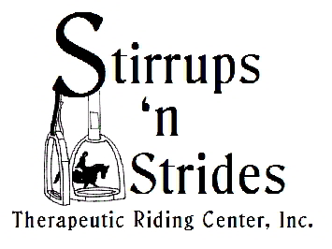 **STIRRUPS ‘N STRIDES**

**SPRING INFORMATION SHEET**

What a busy season we have had this year!!! **The Country Hoedown** in December was fantastic! With close to 300 people attending, 110 baskets to try & win & wonderful entertainment everyone had a great time. It was a great fundraiser! A big thank you goes out to all our rider families & volunteers for making great theme baskets & putting in many volunteer hours. Elaine Richter did a great job again in putting this event together & Catherine Sears put a great show together with so many wonderful entertainers. Watch for next year’s date! For the 4th annual Country Hoedown.

**The Challenge Show** in February was a huge success with 76 riders attending from Florida & Georgia. Stirrups ‘n Strides had 23 riders that did an awesome job, I was so proud of everyone. Our 55 volunteers are the best! They made this show run very smooth & I want to thank everyone for taking your day to make it a special day for so many.

**Special Olympic Area Games** –Area Games was held on April 5th this year at Stirrups ‘n Strides & we had 21 riders competing. It was a wonderful day; with 18 riders from other Centers competing we had a total of 39 riders in all. Our volunteers were the best & the show ran very smoothly. A big Thank You goes out to Jim Olson & Debbie Paisley for being our Judges, Conky Price our announcer, the Ocala West Methodist Church for hosting the Food Court & also our wonderful rider families & volunteers who brought great bake sale items! The food was just the Best. Thank you everyone, we could not hold such a show without everyone’s help.

* May 2nd & 3rd – State Special Olympics at the Grand Oaks in Weirsdale. We have been given a quota of 14 athletes for State Games. Being closer to home this year will be nice; we will ship our horses to the show on Thursday to get them ready for showing on Friday & Saturday. We have 20 volunteers signed up to help, thank you all, we will need everyone with so many riders. This is really a fun show & our athletes have a good time. If you have any time on Friday evening or Saturday come & cheer on our riders.
* May 31st – this is the last day of riding for our winter/fall session
* May 31st – will also be our “End of the Year Party” – we will have our Saturday classes & then head to the party!! This will be pot luck so please plan to bring your favorite dish to share. Stirrups ‘n Strides will provide hamburgers & hotdogs. Bring your swim suits & enjoy the pool.
* July 8th- August 12th - Our summer 6 week riding session. This will be on a Tuesday morning and limited to 10-12 riders. See Betty if you are interested. Volunteers also are needed!!!
* Come cruise with us next February 22nd-March 1st. see Betty for more info