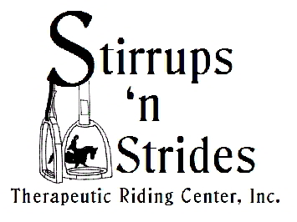 **STIRRUPS ‘N STRIDES**

**Summer/Fall INFORMATION SHEET**

Wow! Has it been hot this summer? We are in the middle of our summer riding session with two classes on Tuesday mornings. We have 15 riders riding at 8:30 & 9:30. A big thank you goes out to all our fantastic volunteers that are here helping with the summer program, hopefully everyone will survive this hot weather. This session will end on August 12th & then the fall program will start up on September 30th & run until the end of May.

**May 2nd & 3rd** was the State Special Olympic show at the Grand Oaks in Weirsdale. We took 14 athletes to compete & what a great job they did. Stirrups ‘n Strides brought home 11 Gold, 9 Silver & 3 Bronze medals. I am so proud of all our riders, they all work so hard, & of course we had over 20 volunteers at the show to help make everything run so smooth, even in the rain! A big Thank You goes out to all our volunteer’s; you are the backbone of our program.

**May 31st** – our End of the Year Party was great as usual. We had over to 100 family members, riders & volunteers in attendance. The food was outstanding, nothing like pot luck!! Everyone brought their favorite dishes to share. Our volunteer’s voted for the “Horse of the Year” award & “Fritz” won for the 2013-2014 riding year. It was a close call with Poncho & Stewart only a couple votes behind. Our “Outstanding Volunteer” award was shared by 2 very special ladies this year. Pat Lepak was chosen for her outstanding dedication of Stirrups ‘n Strides. Every time our program is running, Pat is sure to be here; if you want to find Pat on Tuesdays, Wednesdays, & Saturdays just come on over to Stirrups ‘n Strides she will be here. Our other “Outstanding Volunteer” went to Elaine Richter. Elaine spends countless hours in putting our Country Hoedown fundraiser together every year for the past 3 years! Not only does she work on our fundraisers, Elaine can be seen out in the arena if we need her. A big thank you to 2 very special ladies.

**May 5-7** - is the Summers End Horse Show at the Livestock Pavilion in Ocala. Not only will be taking riders to compete, we will have our annual silent auction there to help our riders go to Kansas City in November for the Exceptional Challenge Cup Finals. If you have something you would like to donate for the auction, please let me know; we will need volunteers also!

**September 20th**. – Mark your calendars, this is Volunteer Orientation. All volunteers both returning & new are asked to attend. Everyone needs a refresher, so please keep this date open.

**September 30th** – this is our 1st day of fall/winter/spring riding. Hope to see you all there.

**September 26th**- Mark your calendar; come join us for a Premier Jewelry Party on Friday night at 6:30 at Stirrups ‘n Strides. It is a fundraiser! Good food, spirits & fun!!! Call Betty for info.

Come cruise with us next February 22nd-March 1st. see Betty for more info: 352-427-3569